**Data Generation Project v1.0**

This set of workflows in ArcGIS Pro will allow you to create new fictitious sample data to use for tests, demos, etc. The data resembles timestamped points, thousands of them, each with their own staggered starting time. The points follow unique paths and move at the speed you specify. They can therefore resemble wildlife, trucks, hikers, etc. The workflow creates two sets of datapoints: blue and red.

**Blue Pts Creation - The blue point data creation workflow resembles the path along a known route, such as a trail, or patrol. That workflow creates identical sets of points moving along the trail with a regular temporal departure offset and a speed that you configure.**

**Blue1 – Create Single Path Template**

Purpose

– Rnsure the blue ‘patrol’ line has nice vertex spacing

Input – pathtemplate line

Output – line with correctly spaced vertices, pts of those vertices

**Blue2 – Append Additional Paths**

Purpose

* Copies and self appends the linetemplate line X amount of times to reflect X number of Patrols

Input/Output – pathtemplate

Variable – number of patrols

**Blue3 – Create Path Routes**

Purpose

* Creates a route type of line that can store a linear measure value
* Adds some zeroed out fields to store timeoffsets

Input/Output – pathtemplate

**Blue4 – StaggerPathTimeOffset**

Purpose – Calculates a number of seconds to offset each patrol from the prior patrol’s departure time

Input/Output – pathtemplate

Variable – offset in minutes

**Blue5 – Create Path Event Temporal Points**

Purpose

* Turns the blue lines into points at each vertex
* Inserts a zero value into Point_M field if it is null
* Calculate a time stamp for each point using the measure value multiplied by a speed to get a time, and add the offset to that time

Red Points Creation – These are temporal points that each follow a seemingly random path from an origin linear location to a destination area. They could represent the migration of people from a starting line to a finishing area. The points all are temporarily offset and the path they follow is logical because a network is created from data that you supply.

Create fictitious network of trail/road segments, (or use an existing one).

First create a new line featureclass and just scribble all over the map to digitize the lines to represent the various trails. Make sure there are enough intersections so a network can actually exist. Here is what you are trying to create.

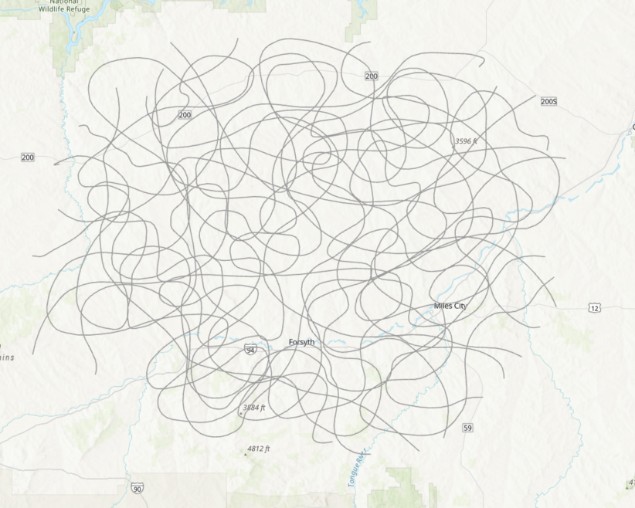

Next create a starting line, rebaseline (red line below), and a destination polygon zone, redtarget area (purple poly below).

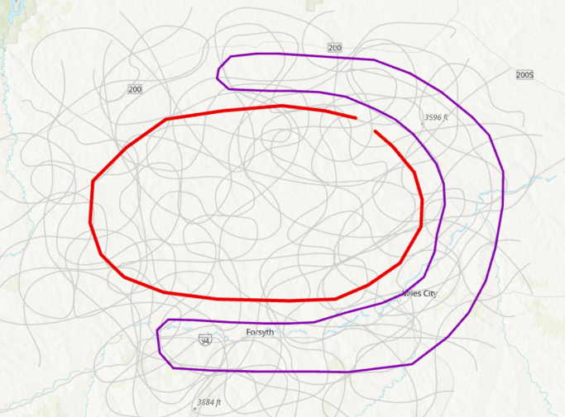

The model will create random points in each as starting and ending pairings.

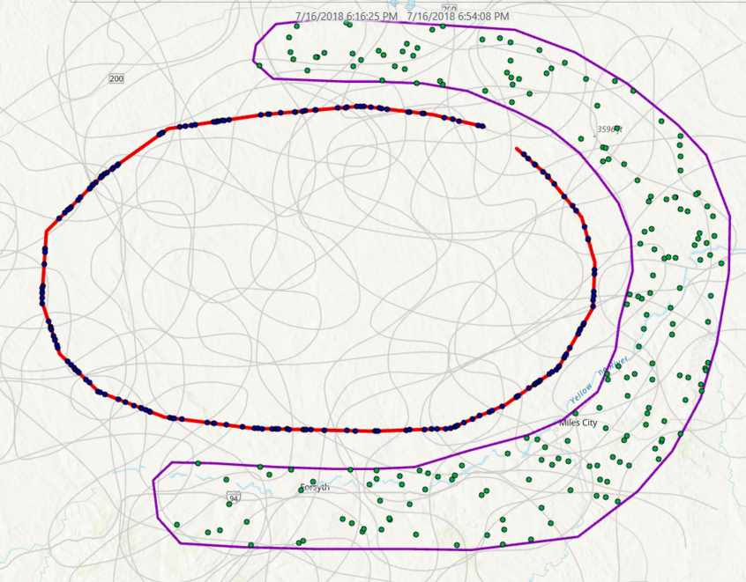

Then find routes

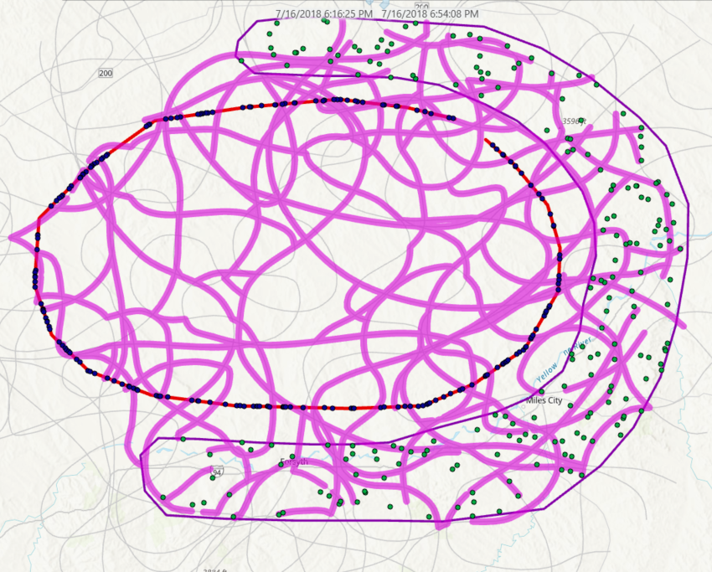

Then find routes (here you are seeing only a segment in time)

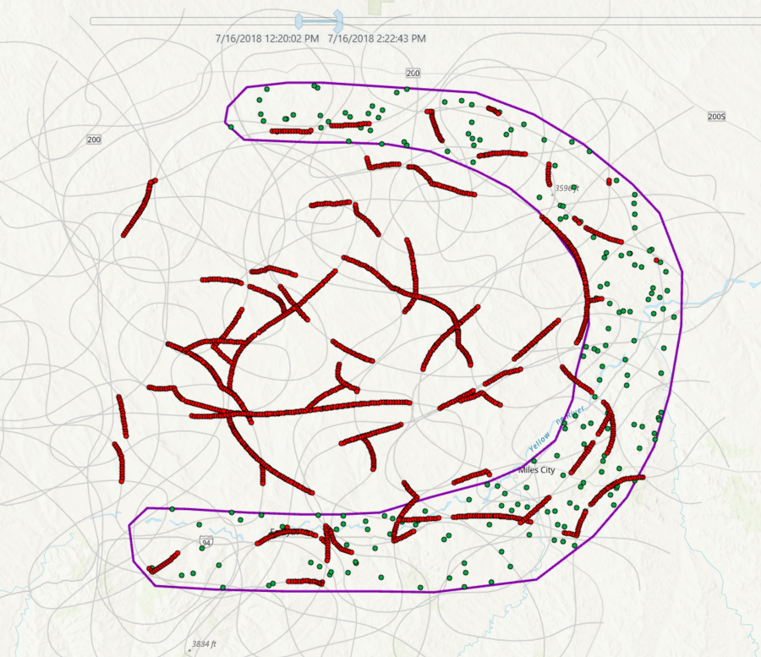

Then overlay the blue and find intersections in time and space:

